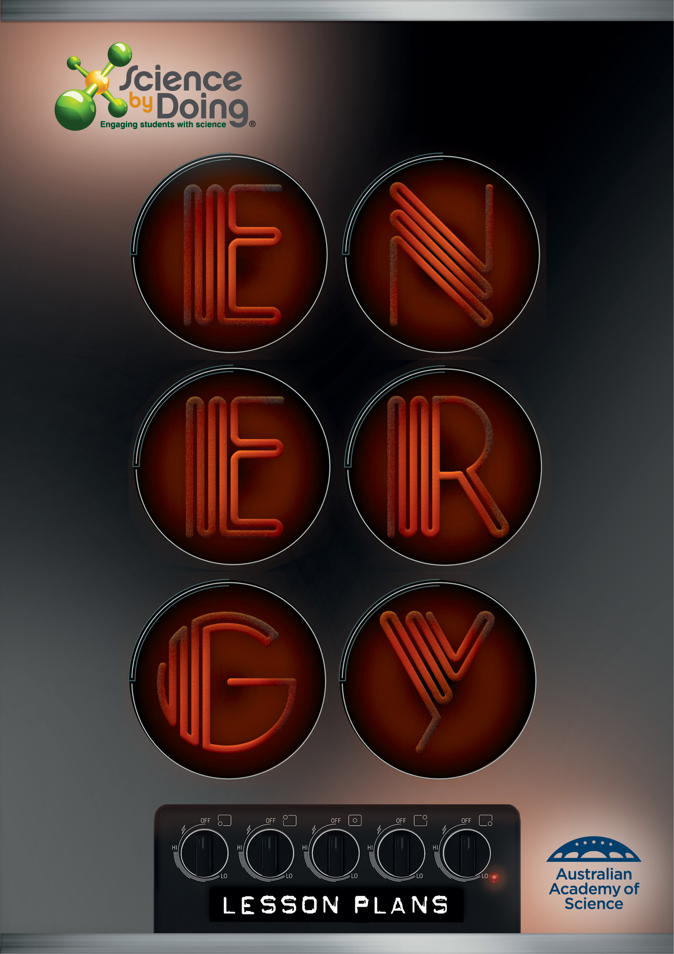

User Guide

Word for PCs
For ease of navigation we suggest you turn on the Navigation Pane located under the View tab in the menu bar.
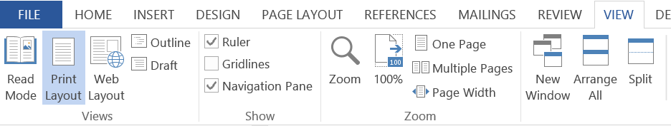

Word for Mac
For ease of navigation we suggest you turn on the Document Map Pane located under the View tab in the menu bar. Select the View tab, select Sidebar then Document Map pane.

This will open up a clickable Navigation column on the left hand side of the document.

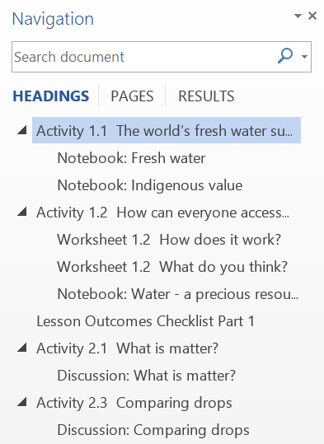

You can select the various elements of each Activity and move through the document with greater ease.

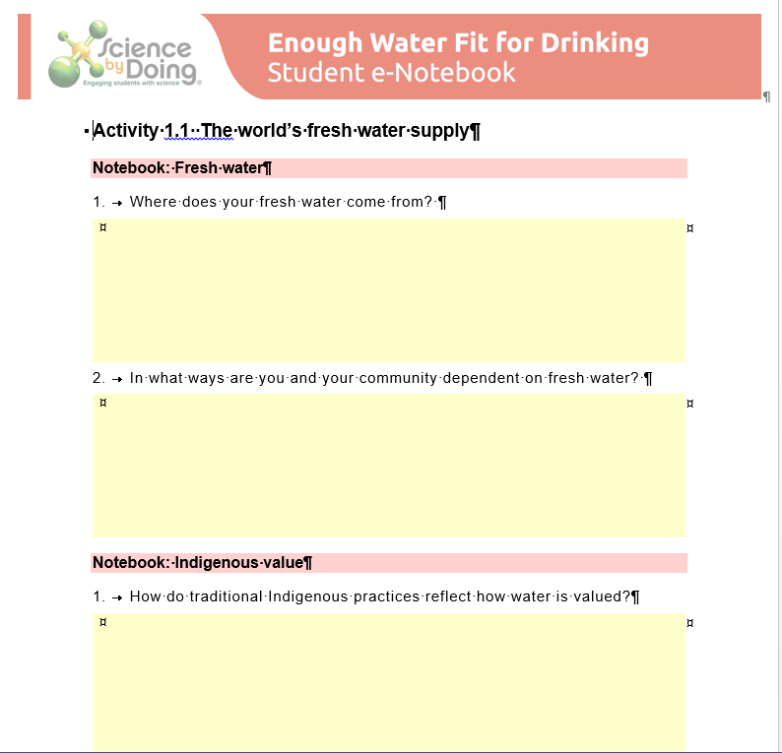

Activity 1.1 Spot the energy
Watch the animated scene in the Student Digital carefully
- How many different types of energy can you see?
- Think back over this exercise. What clues suggested energy was involved in different parts of the scene?
The Find out More link provides a summary of some of the energy forms you have seen.
Now apply your understanding to the exhibits that your teacher has set up in your classroom. For each exhibit describe the energy forms that you observe in the table below.
Exhibit name | Energy forms present

Activity 1.2 Energy to burn
Watch the video of the launch of the Apollo 11 mission, the first mission taking men to the Moon.
Record all the energy types you could observe during the launch.
Energy type | What it looked like

Lesson Outcomes Checklist Part 1
NAME:
ACTIVITY | LESSON OUTCOMES  At the end of these activities I can: | Please indicate if you achieved each learning outcome:  = Yes  ? = Partly  X = No
Activity 1.1 Spot the energy | - recognize when energy is being transformed in different situations
 | - identify different energy stores at the beginning and end of processes and events.
Activity 1.2 Energy to burn | - share my ideas about what types of energy are evident during a rocket launch
 | - recognise that various changes indicate energy is involved
 | - identify that energy can be transformed
Activity 1.3 Forms of energy | - identify energy forms in a photograph using appropriate scientific terms
 | - clearly label a photograph so that information about energy forms is clearly communicated to another person.

Activity 2.1 Throw the ball
1. What makes the ball fly into the air?
2. When is the ball travelling the fastest?
3. When is the ball travelling the slowest?
4. What happens to the motion of the ball as it rises and falls?

Activity 2.1 Throw the ball

5. In the video, how did the downward motion of the thrown ball compare to that of the dropped ball?
6. How did the thrown ball originally get its energy? How did the dropped ball get its energy?

Notebook: Mechanical Energy
1. Summarise how kinetic energy (KE) and gravitational potential energy (GPE) are involved in the flight of a ball thrown into the air.
2. When did the ball have the most KE?

3. When did the ball have the most GPE?
4. How did the ball get its energy at the beginning?
5. Draw a simple diagram showing how KE and GPE are transformed during the flight of the ball.

Activity 2.2 Energy skate park

Notebook: Mechanical energy analysis
1. How high up the ramp do you have to start the skater so that he can get over the middle hump?
2. Where is the gravitational potential energy the greatest?
3. Where is the kinetic energy the greatest?
4. What happens if you change the mass of the skater?

Now turn on the Friction
5. What difference does the friction make to the motion of the skater?

Discussion
6. How can the ideas of kinetic energy and gravitational potential energy be used to explain the motion of the skater?
7. How is the conservation of mechanical energy demonstrated in this activity?
8. How does the skater put energy into the system?

Activity 2.4 Heat from friction
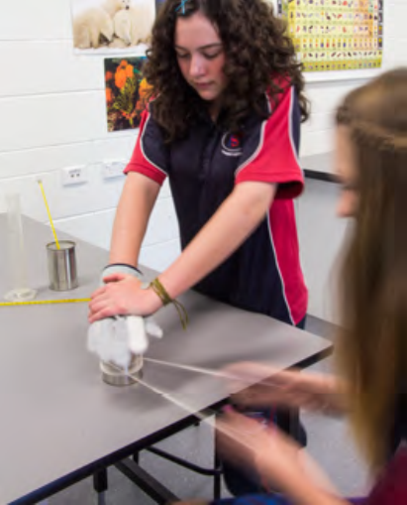

Discussion
1. Was there a difference in temperature between the can the string was rubbed on and the control can?
2. Did you put mechanical energy into the can? Did it move?

3. What happened to the energy you put in?

Activity 2.5 Starting fires

Notebook: How were fires started before matches?
The Aborigines in the video have followed careful steps to light their fire.
1. Describe what steps they took and why these were important.
2. Explain why rubbing the sticks together is important. What energy transformation is taking place?
3. Explain why they blew on the ember to help the fire start.
4. How do these fire-starting techniques relate to mechanical energy?

Activity 2.6 Putting it together

Putting it together: Quiz
You may refer to your Notebook.
Question 1 (Energy forms)
Name six different forms of energy and provide an example of each:
Energy form | Example
Question 2 (Energy transfers)
Give an example of each of the following energy transfers:
Mechanical energy to heat energy:
Gravitational potential energy to kinetic energy:

Electrical energy to sound energy:
Chemical energy to kinetic energy:
Question 3 (Mechanical energy)
A student throws a ball into the air and then catches it as it comes down. Explain how this shows that mechanical energy is conserved:
Question 4 (Pulleys)
A student designs the simplest block and tackle (pulley) system to lift a heavy rock alone. The rock has a mass of 120 kg and the student has a mass of 39 kg. The student finds that he can use his own body weight on this pulley system to lift the rock.
What is the mechanical advantage of this pulley system?

If he wants to lift the rock one metre, how much rope must be hauled through the pulley?

Question 5 (Starting fires)
Write a paragraph describing the energy transfers involved in starting a fire using the drill method.
You should include the following terms:
Mechanical energy
Kinetic energy
Heat energy
Light energy
Chemical energy

Discussion
1. Identify all the energy transformations shown in the Student Guide.

2. Were any sections particularly difficult?

Lesson Outcomes Checklist Part 2
NAME:
ACTIVITY | LESSON OUTCOMES  At the end of these activities I can: | Please indicate if you achieved each learning outcome:  = Yes  ? = Partly  X = No
Activity 2.1 Throw the ball | - apply the concepts of kinetic and gravitational potential energies to explain the throwing of a ball
 | - explain how the concept of conservation of mechanical energy accounts for the motion of the ball
Activity 2.2 Energy skate park | - apply the concepts of kinetic energy and gravitational potential energy to the motion of a skater
 | - explain how the concept of conservation of mechanical energy can be used to account for the motion of a skater.
Activity 2.4 Heat from friction | - explain that movement energy can be converted to heat through friction
 | - explain that the transfer of heat energy can be recognized through the rise in temperature of a substance.
Activity 2.5 Starting fires | - apply their understanding to explain that fire required:  - mechanical energy to cause friction, producing heat up to ignition temperature  - fuel with a low ignition temperature  - oxygen
 | - relate these ideas to how people in the video clips made fire using the rubbing and drill and bow methods

Activity 2.6 Putting it together | - apply their understanding of energy forms and mechanical energy transfers to a variety of situations and contexts apply their understanding of energy forms and mechanical energy transfers to a variety of situations and contexts
 | - explain a range of energy transformations.

Activity 3.1 What is heat?

Notebook: Testing the caloric theory
Watch the animation about Lord Rumford and his experiments with the boring of cannons. It is in three sections so you can answer the following questions in turn.
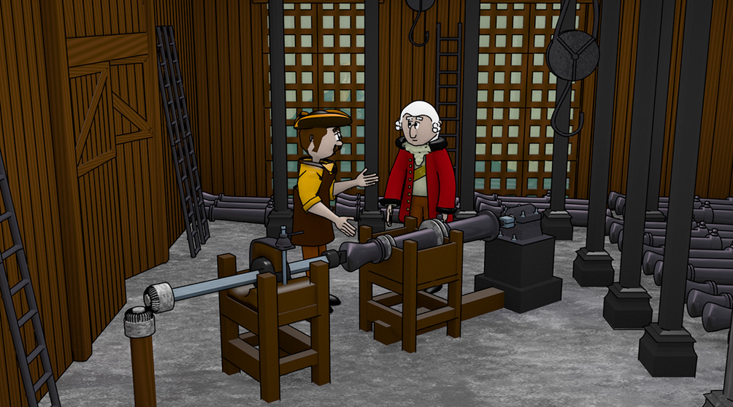
Animation 1: Can you think of a fair test of Rumford’s idea about heat being caloric fluid?

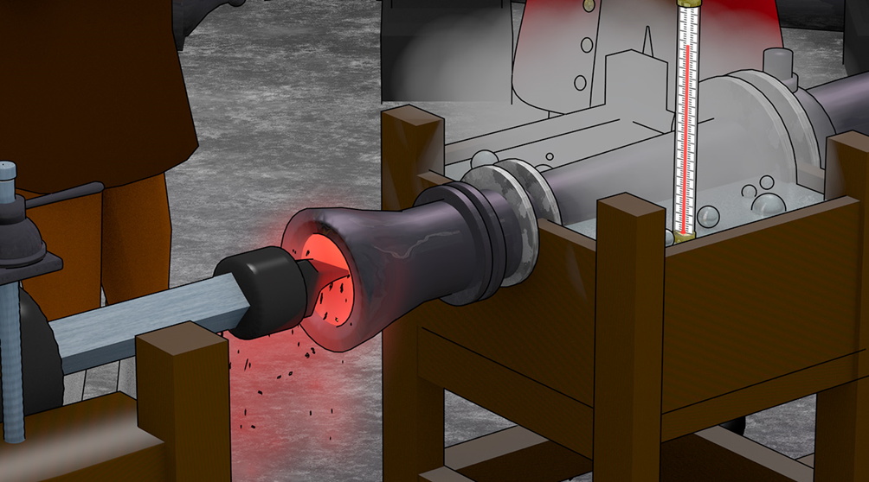
Animation 2: What results would you expect to see?
What results would you expect if the theory of caloric fluid was correct?

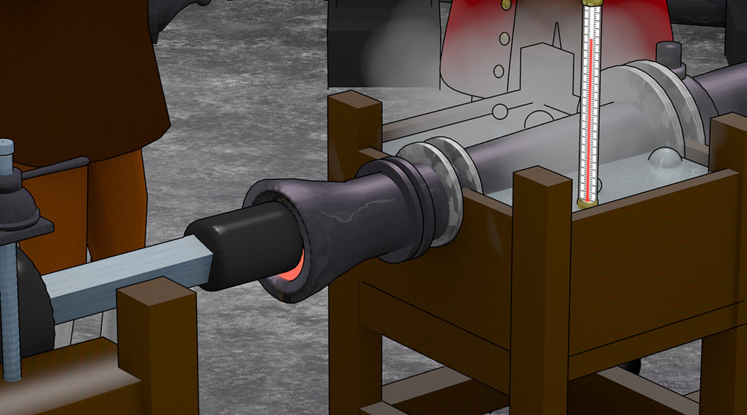
Animation 3: How did Rumford’s observations disprove the caloric theory?

Discussion:
People had observed that the cannon barrels got very hot when they were being bored out. Cannon barrels were known to become hot when bored out.
1. What was Rumford’s hypothesis?

2. Rumford proposed a fair test. Describe it.
3. Why was it a good test of his hypothesis?
4. The results were surprising. What were the observations?
5. Did these results support or disprove Rumford’s hypothesis?

Activity 3.2 Keeping your drink warm
Experiment 1

Discussion
1. Did you feel heat coming from the side of the hot beaker when you touched it?
This is called “conduction”.
2. Did you feel hot air rising from the surface of the hot water?
This is called “convection”.
Experiment 2

Discussion
1. What can you conclude from this experiment?

2. How did the heat loss from the two experimental beakers compared with the heat loss from the control beaker?
3. What was happening at the surface of the hot drink that would have contributed to the heat loss?

Activity 3.3 Water is hard to heat
Experiment 1

Discussion
Explain: In this experiment did the hot water become cooler? Where did the heat go?
Experiment 2

Discussion
Was there a difference in the “capacity” of 100 mL of cold water compared to the “capacity” of 100 g cold brass to cool down 100 mL of hot water? Which one worked better?

Activity 3.4 Feeling hot and cold

Notebook: Conducting heat
1. When Dr Muller asked people to hold the piece of aluminium and the piece of plastic in their hands, which one did they say felt coldest?
2. Which one did they predict would melt the ice faster?
3. Which one did melt the ice faster?
Explanation
In your own words, how did Dr Muller explain the results of this experiment?

Did you replicate this experiment yourself?
How did your friends or family respond to this demonstration? What predictions did they make about the melting ice?
Explain why the person in the picture is able to hold the red-hot thermal tile in his bare hands. Use the term “thermal conductivity” in your explanation.

Activity 3.5 Heating water with light

Discussion
1. Was there any variation between the results from different groups?
2. Which results were consistent across the different groups?
3. What do you think is the advantage of pooling the class data in this way?
Write a conclusion discussing which surface absorbed the most light energy and changed it into heat energy.

Activity 3.7 What is sunlight?
Experiment
Sketch of spectrum I produced (identify the colours clearly visible to you).

Notebook
1. How many colours are visible in the spectrum of light from the sun?
2. What invisible types of light also come from the sun?
3. What happens when light falls on a black surface?

4. What happens when light falls on a green surface?
5. What colours do plants absorb for photosynthesis? (See Find Out More).
6. How fast does light travel through a vacuum?
7. The moon shines because it reflects sunlight. How long does it take the reflected light to travel from the moon to Earth? The moon is 384,000 km away.

Activity 3.8 Cyclones

Notebook: What drives a cyclone?
Click on the image in the Student Digital page to visit About Tropical Cyclones on the Bureau of Meteorology (BoM) website and answer these questions.
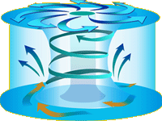
1. How strong are the winds in a cyclone?
2. How warm does the ocean have to be for a cyclone to form?
3. What is a cyclone storm surge?

4. Cyclone Debbie had winds over 250 km/hr. What category cyclone was it?
5. Use the map shown at the bottom of the BoM website to list the major towns and cities that have been hit by cyclones.
6. Which Australian capital cities are unlikely to be hit by a cyclone?
7. Do you live in a cyclone-prone area?

Lesson Outcomes Checklist Part 3
NAME:
ACTIVITY | LESSON OUTCOMES  At the end of these activities I can: | Please indicate if you achieved each learning outcome:  = Yes  ? = Partly  X = No
Activity 3.1 What is heat? | - describe how Count Rumford’s observations provided evidence against the caloric theory
Activity 3.2 Keeping your drink warm | - describe mechanisms of heat transfer: convection, conduction and evaporation
 | - apply the concepts of heat transfer through convection, conduction and evaporation to the problem of keeping a drink hot.
Activity 3.3 Water is hard to heat | - correctly apply the terms heat and temperature
 | - understand that not all objects of the same mass and at the same temperature have the same heat content
 | - understand that heat is transferred from objects at a higher temperature to objects at a lower temperature.
Activity 3.4 Feeling hot and cold | - explain how the conduction of heat relates to whether surfaces feel hot or cold
 | - understand objects in contact in the same environment will come to the same temperature
Activity 3.5 Heating water with light | - demonstrate heating water with light
 | - provide evidence that dark surfaces absorb more light energy than light coloured surfaces.

Activity 3.6 Solar energy | - apply my understanding of heat and light to design a solar collector to successfully heat water
 | - evaluate the effectiveness of my solar heater by taking appropriate measurements.
Activity 3.7 What is sunlight? | - explain that sunlight is a mixture of visible light and invisible ultraviolet and infra-red light.
 | - describe the visible spectrum
 | - understand that light is a way energy can be transferred through the vacuum of space.
Activity 3.8 Cyclones | - describe the overall structure of a cyclone
 | - explain how heat is involved in the formation of a cyclone
 | - explain how the evaporation and condensation of water contribute to the formation of a cyclone

Activity 4.1 Making a globe light up

Discussion
What was required to make your globe light up?
Summarise your findings. Include a diagram showing how your circuit was set up.
If you did the challenge activity, then describe your circuit. Include a sketch.

Activity 4.3 Heating with electricity
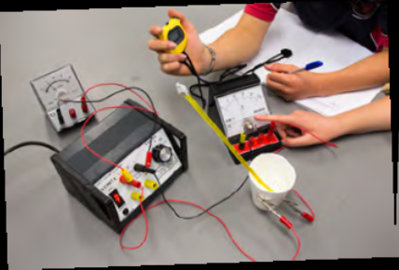
Table for class results
Voltage (Volts) | Current (Amps) | Power (Watts) = Voltage x Current | Temp. increase (ºC) in 150 mL of water in 15 minutes
Graph of energy used against increase in temperature.
You could insert a graph from an Excel file of the class results.

Discussion
1. How did the temperature increase of the water compare with the power of each heater?
2. What do you think would have happened to the temperature increase in your heater if you had doubled the time of heating?

Activity 4.4 Build a motor

Discussion
1. Did your motor need a complete circuit?
2. What energy transformation did your motor achieve?

Activity 4.5 Build a generator

Discussion
Did the needle move when you passed the magnet in and out of the coil?
Was it a large effect?
What sort of energy is being transformed to electrical energy?

Activity 4.6 The lemon battery

Discussion
What energy conversion was happening in your lemon battery?
Sketch your lemon battery or insert a photograph.
Where did the energy in your lemon battery come from?

Lesson Outcomes Checklist Part 4
NAME:
ACTIVITY | LESSON OUTCOMES  At the end of these activities I can: | Please indicate if you achieved each learning outcome:  = Yes  ? = Partly  X = No
Activity 4.1 Making a globe light up | - describe the requirements for lighting an electric globe
 | - understand every electric circuit requires a source of electrical energy and a complete circuit
Activity 4.2 Showing electric circuits | - interpret circuit symbols
Activity 4.3 Heating with electricity | - explain how a circuit can be built to heat water
 | - understand most electric circuits transform some electrical energy to heat
 | - calculate the quantity of heat transformed in a circuit
Activity 4.4 Build a motor | - build a model motor and describe its major components
 | - describe how electrical energy can be transformed into kinetic energy.
Activity 4.5 Build a generator | - build a model generator and describe its major components.
Activity 4.6 The lemon battery | - construct a battery made of lemons and copper and zinc electrodes
 | - explain that the energy to power the battery ultimately comes from the chemical energy in the metal electrodes

Activity 5.1 Food as fuel

Discussion
Calculation of heat energy absorbed by the water
It takes 4.2 Joules of energy to heat 1 mL of water by 1ºC.

 | X |  | X | 4.2 | =
Temp rise in ⁰C |  | Vol of water in mL |  | Conversion factor: specific heat of water |  | Total energy of the nut in Joules

Activity 5.2 Energy in food
Food name | Energy kJ/100g) | Food molecules where most of this energy comes from

Discussion
Which food molecule contributes the most energy to foods?

Notebook
Insert your Nutrition Information Panel (NIP) for your pikelets here.

Activity 5.3 Who eats what?
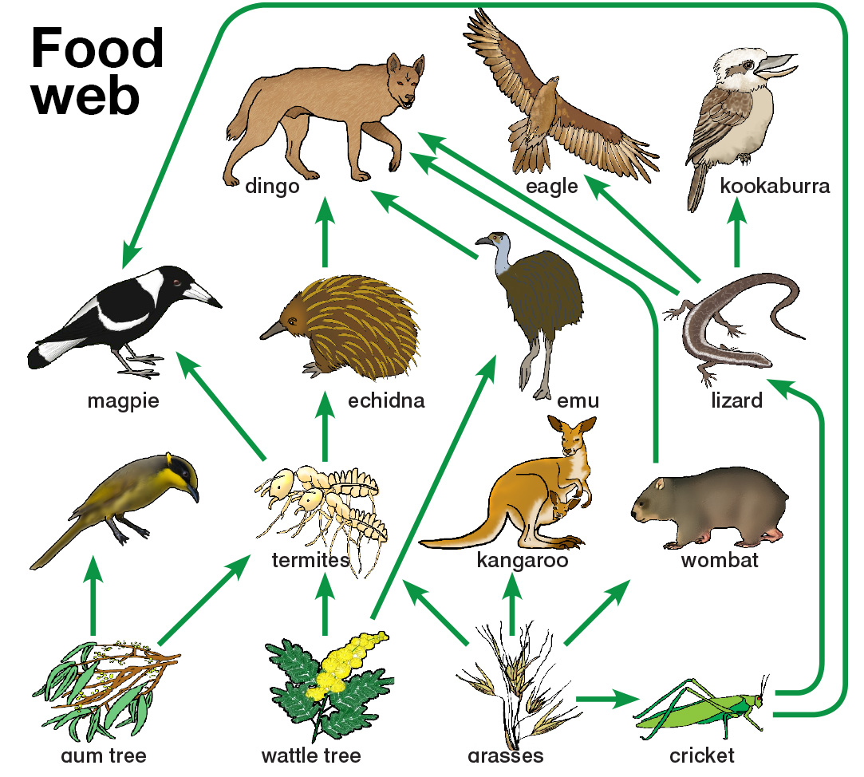
1. Draw two different food chains from the food web shown in the Student Guide.
2. Describe the top predators in this food web.

3. What energy form is being passed through each food chain?
4. Each food chain only has arrows going in one direction and do not include cycles. Where does the energy finally end up?
5. An eagle has a high demand. Using correct sentence structure write a paragraph that explains how an eagle gets its energy. Make sure you track the energy story back to its origin.

Activity 5.4 Rates of photosynthesis
Access the link to the photosynthesis simulation.
Write down the three most important things you need to understand about photosynthesis.

Investigation of photosynthesis
What to do:
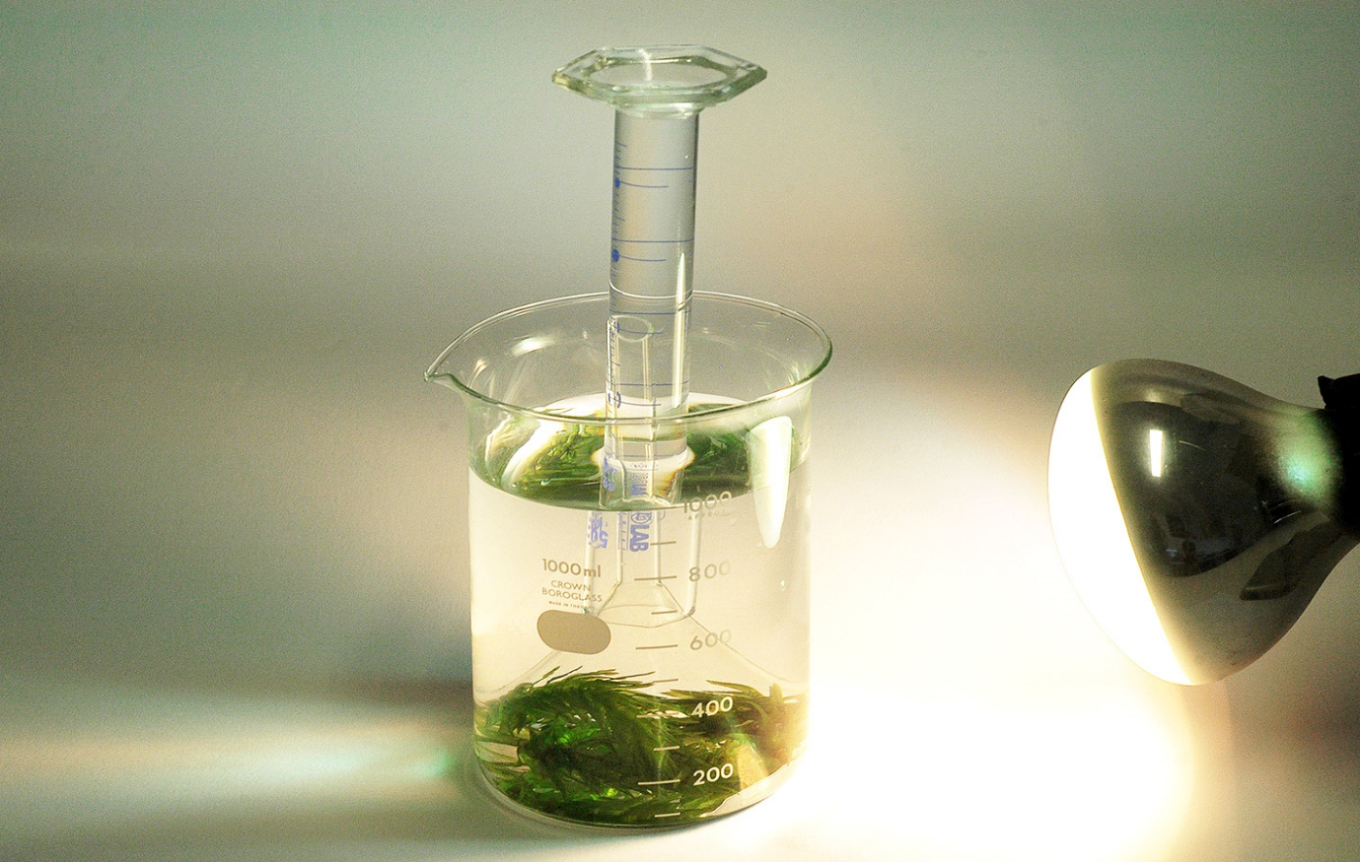
Record which factors could affect the rate of photosynthesis.
State the question you will be investigating. If you have formulated a hypothesis then state this as well.
Method: describe what you did in your investigation. (Write this in past tense, because it describes what you did. Include a sketch of your experiment.

Discussion
Describe the results of your experiment
Write a conclusion with an answer for your question.

Lesson Outcomes Checklist Part 5
NAME:
ACTIVITY | LESSON OUTCOMES  At the end of these activities I can: | Please indicate if you achieved each learning outcome:  = Yes  ? = Partly  X = No
Activity 5.1 Food as fuel | - safely conduct a heating experiment involving a flame
 | - accurately measure the rise in water temperature
 | - calculate from the temperature rise of a water sample the quantity of heat energy a burning nut releases
Activity 5.2 Energy in food | - access information about the energy content of foods from the nutritional information provided
 | - compare the energy contents of different foods, accounting for their different weights
 | - relate the energy contents of different foods to average daily requirements
 | - use the Nutrition Panel Calculator to produce Nutritional Information Panels
Activity 5.3 Food chains and food web | - construct and interpret food chain and food web diagrams
 | - understand that food chains and food webs show how energy is transferred through ecosystems

Activity 5.4 Photosynthesis | - describe factors that affect the rate of photosynthesis
 | - explain the overall photosynthesis reaction and word equation
 | - design a simple experiment to investigate a factor that affects the rate of photosynthesis

Activity 6.1 Where does our energy come from?
1. The cleanest fossil fuels to burn in power stations are black coal, gas, and oil. What percentage of Australian electricity is produced using these fuels?
2. Make a list of the renewable resources used.
3. What percentage of Australia’s electricity is produced from renewable resources?
4. What is the most common form of renewable energy used to make electricity in Australia?

5. Gas turbines, which run on natural gas, are sometimes used for peak demand, as they can be quickly turned on. When does peak demand usually occur? How could you find out?
Student digital exercise
Draw a sketch of the energy chain that occurs when coal is burned to produce electrical energy.

Activity 6.2 Energy systems

Notebook
Here is a Sankey diagram of the energy used in an typical Australian household.
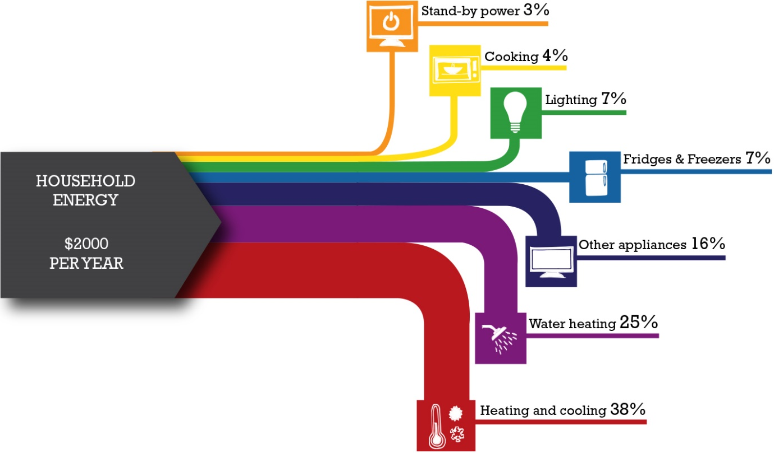
1. What are the two biggest energy users in this household?
2. List the appliances in your house

3. Based on this diagram where do you think you could save the most energy overall?
4. Find out the average energy use in your area?

5. Household electrical energy is measured in kilowatt hours (kWh). The average cost of electricity is 20 cents per kWh. What is the average total cost of electricity used in a household in your area?

Activity 6.3 Conserving energy
What to do:
Reducing heat loss and gain from a house.
Heat loss or gain | Possible ways to prevent
Designing an energy efficient house
Include a sketch or photo of your model house.
List the design features included in your house.
Explain why you used each one.

Activity 6.4 Honda ad

Notebook
List all the energy transfers and transformations you saw happening in the video.
Describe the places where energy was stored in the system. What form was it stored in?

Lesson Outcomes Checklist Part 6
NAME:
ACTIVITY | LESSON OUTCOMES  At the end of these activities I can: | Please indicate if you achieved each learning outcome:  = Yes  ? = Partly  X = No
Activity 6.1 Where does out energy come from? | - describe the processes that deliver electrical energy to cities and towns
 | - explain the energy transformations that take place in the production of electricity in power stations
 | - describe some aspects of electricity production and transmission in my local region
Activity 6.2 Energy systems | - explain the use of Sankey diagrams to illustrate the energy transfer through complex systems
 | - apply my understanding of a Sankey diagram to propose areas where energy could be saved in a complex system such as the family home
Activity 6.3 Conserving energy | - build a model of an energy-efficient house, applying their understanding of heat transfer
 | - explain how I have applied my understanding of heat transfer in the design of this house
 | - conduct an evaluation of the efficiency of my house model
Activity 6.4 Honda ad | - apply many aspects of my understanding of energy forms, stores and transfers and transformations to a video involving many physical interactions

Acknowledgements

Science by Doing is supported by the Australian Government Department of Education, Skills and Employment. The views expressed here are those of the author and do not necessarily represent the views of the Australian Government Department of Education, Skills and Employment.
Copyright
© Australian Academy of Science, 2021
Energy, Student e-Notebook: ISBN 978-0-85847-799-5
Published by the Australian Academy of Science
GPO Box 783
Canberra ACT 2601
Telephone: 02 6201 9400
www.science.org.au

The details of the relevant licence conditions are available on the Creative Commons website (accessible using the links provided) as is the full legal code for the Creative Commons Attribution-NonCommercial-ShareAlike 4.0 International (CC BY-NC-SA 4.0) licence (https://creativecommons.org/licenses/by-nc-sa/4.0/legalcode).
Click here for a full version of unit acknowledgements and sources or logon to www.sciencebydoing.edu.au.
Last revised: 29 October 2021

